Frequently Asked Questions
Border Control Posts

From the 31st of January 2024 certification has become mandatory when importing medium risk veterinary and phytosanitary products into the United Kingdom (UK). Additionally, from the 30th of April 2024, apart from the certification, the British Government will start with physical inspections of these products in the Border Control Posts (BCPs).

To inform you to the best of our ability, we have created this FAQ in hopes to answer your questions.

- What are phytosanitary and veterinary products?
Phytosanitary: relating to the health of plants. Phytosanitary products are for example, among others, plants, cut flowers, flower bulbs and root tubers.

Veterinary goods may include dairy, eggs, poultry meat, manure and dung pellets, fish & fish products, etc.

Phytosanitary and veterinary products may pose risks to animal health, food safety and biosecurity, and public health, alongside the risks specific to the country of origin e.g. the prevalence of pests/diseases and the standard of official health controls.
Therefore, a health certificate is required for these products and all high risk products are subject to inspection as well to ensure the products are safe to be imported and used/consumed. From the 30th April 2024 a number of medium risk products will also become subject to inspection when entering the UK.

- What is a BCP?
BCP stands for Border Control Post. Within the BCPs the following products are inspected:
- Live Animals
- Germinal Products
- Product Of Animal Origin (POAO)
- Plants and plant products
- Animal By Products (ABP)
- High Risk Food and feed Not of Animal Origin (HRFNAO)
- Composite Food products
- For Harwich, Killingholme, Immingham also UK Border Force Checks

- What changes exactly?
In short, health certification on medium and high risk Sanitary and Phytosanitary EU goods has been required from the 31st of January with physical checks for high risk products. Additionally, physical checks will be introduced for medium risk products from 30 April 2024 as well.

Below the specifications of the changes on 30 April 2024 (BTOM p.56):

From 30 April 2024, a new global risk-based import regime for both EU and non-EU
goods will be implemented. Specifically:
- The new checks at the border on medium risk EU origin goods will be introduced (except at West Coast GB ports).
- All goods to which import health controls apply will be required to enter via a point of entry that has the relevant Border Control Post or in the case of plants or plant products a Control Point designation for those goods.
- Health certificates and routine checks at the border will no longer be required for low risk animal products for import from non-EU countries with the exception of intelligence-led interventions on low risk animal products.
- The requirements for import controls on certain low risk plants and plant products from non-EU countries will start to be removed, where supported by risk assessments. Health certificates and routine checks at the border will not be required for such products.
- Medium risk animal products will be subject to reduced levels of intervention at the border with identity and physical check levels being lower than now for imports from non-EU countries.
- The introduction of Common Health Entry Documents (CHEDs) for all live animal,
HRFNAO (High Risk Food and Feed of Non-Animal Origin) and animal product imports from the EU is required to support the introduction of identity and physical checks from the end of April 2024. CHEDs will replace the Import Notifications (IMPs) currently required for live animal, HRFNAO and animal product imports from the EU. There is currently no HRFNAO of EU origin listed so this requirement refers to where HRFNAO from outside the EU has been placed on the EU market and not been subject to any further processing.
CHEDs for live animal and HRFNAO imports from the EU has been implemented by the end of November 2023, with CHEDs for animal product imports from the EU implemented by the end of January 2024.

- What else will happen on the 30th of April 2024?
On this date there will be changes in the transit document procedure as well, apart from the BCP implementations. All information on this can be found within the following document:
Defra_transiting_goods_through_Great_Britain_leaflet.pdf (publishing.service.gov.uk)

Transit Document with Office of Departure at Immingham
With the opening of the BCP in Immingham on the 30th of April 2024, the Local Reference Number (LRN) to Movement Reference Number (MRN) procedure in Immingham will change. From then on, the haulier will be required to present the trailer together with LRN and obtain the Transit document at Border Force located within the BCP, before check-in.

Once obtained the driver may go to the check-in office to have the Transit Accompanying Document (TAD) MRN added within the ENS and check-in the unit. The driver is responsible for ensuring that the document is placed in the trailer after check-in.

Units without the proper MRN cannot check-in or enter the port for trailer drop-off.

- How do I know if my products are low, medium or high risk products?
We as Stena Line do not have a list for this nor can we determine whether your product falls under the low, medium or high risk category. However, there are several overviews provided by the UK government which show the risk categories per product.

Risk categories of plants and plant products
Risk categories of animals and animal products

You can also find a list of high risk products needing a CHED-D on this webpage.
If you cannot find your product in one of these overviews, then you can take a look at the Get Ready for Brexit website and even send a message to them in case you cannot find the answer.

- Will all medium and high risk products require a physical inspection?
All high risk products will require a physical inspection.
Only a certain percentage of medium risk products will be subject to inspection. This depends on the type of good.

The overviews below, provided by the BTOM, specify these rates.
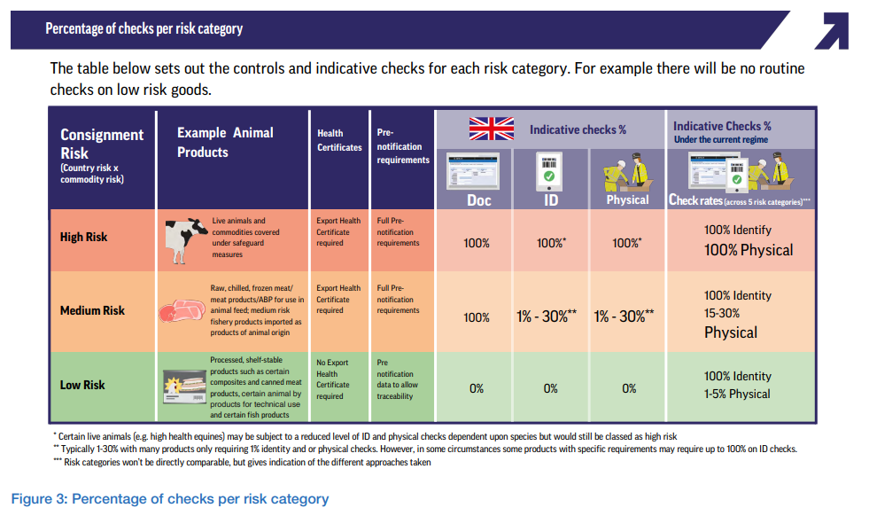
Source: BTOM page 39

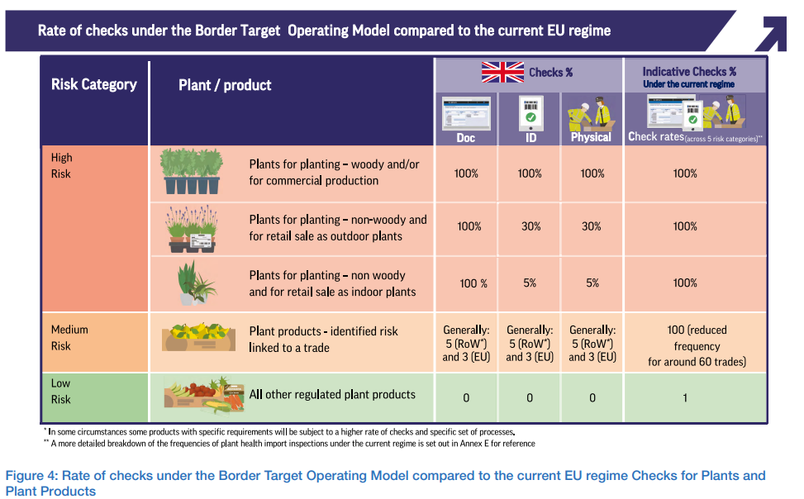
Source: BTOM page 49

- Which products can be inspected within which BCP?
Not all BCPs are allowed to inspect all products. On the governmental website an overview is provided of which products can be inspected within which BCP facility.

- Where can I obtain my health certificates?
A health certificate can be obtained via TRACES (TRAde Control and Expert System).
TRACES is the European Commission's online platform for animal and plant health certification required for the importation of animals, animal products, food and feed of non-animal origin and plants into the European Union, and the intra-EU trade and EU exports of animals and certain animal products.

- Where can I process my health certificates?
The health certificates will need to be added in IPAFFS (Import of Products, Animals, Food and Feed System) before check-in.
IPAFFS is a web-based service for the application for, and issuing of, Common Health Entry Documents (CHEDs) for imports from outside the EU and EEA of live animals, their products and germplasm. IPAFFS is the system used for notifying GB authorities of movements of live animals, their products and germplasm into to GB.

- How long before sailing must the certificates be processed?
Certification has to be uploaded in IPAFFS 24 hours before arrival in the UK.

- What happens if I do not have a certificate made prior to shipment?
Without a health certificate, you will not be able to obtain an import document to enter the UK. In such a case the goods cannot be shipped.

Please do note, Stena Line does not have checks on this as this procedure falls outside of carrier obligations. Therefore, it is the hauliers responsibility to ensure the health certification and the IPAFFS notification have been completed prior to shipment.

- What in case of an EU to EU via UK Landbridge transit (T2)?
A seal check will be required when shipping T2 veterinary or phytosanitary products from the EU into the UK. A physical inspection will only be required if a seal has been broken or removed.
All information on this can be found within the following document:
Defra_transiting_goods_through_Great_Britain_leaflet.pdf (publishing.service.gov.uk)

Please note that Transit SPS holds will not be visible through GVMS, only through IPAFFS. It’s advisable that the declarant adds the haulier and driver details into the IPAFFS declaration contacts field.

- Which BCP can I ship live animals to?
From late 2024, new checks at the border on live animals from the EU will be introduced.
Currently only Sevington has a BCP equipped to inspect live animals.

Port Specific Information
- Where are the BCPs be located?
There are a number of BCPs spread across the UK with their own specialities and limitations. Not all BCPs are allowed to inspect all products. Per category BCPs may or may not be able to inspect specific goods. All active BCPs are listed on the governmental website, including which products they are able to process within the facilities. Via this link you can find a map of the BCP locations.

For our North Sea routes, your goods can be inspected in the BCPs in (exact locations provided on the governmental website):
- Harwich: located on the terminal
- Immingham: located just outside of the terminal
- Killingholme: located on the terminal

- Which location code can I fill in on my certificates?
Harwich: GBHRW1P
Immingham: GBGSY1
Killingholme: GBKIL05

- What will the procedure look like for accompanied shipments in Harwich?
Through IPAFFS there will be a notification to the cargo owner that their unit is selected for inspection.

The cargo owner must inform their driver that the unit must be presented at the BCP facility. The driver can also check GVMS Inspection Lookup Service (ILS) to see if an inspection is required.

In Destin8 the shipment will be put on an inspection hold to ensure the goods will be physically inspected by the BCP before entering the UK. Once the shipment has arrived in the UK, the driver will have to go to the BCP themselves. There will be port operators present to guide the drivers to the BCP.

After inspection, the hold in Destin8 will be removed. If the goods have been customs cleared as well (either via GMR or manual clearance), then the driver may continue their journey to the destination address.

- What will the procedure look like for unaccompanied shipments in Harwich?
Through IPAFFS there will be a notification to the cargo owner that their unit is selected for inspection.
.
In Destin8 the shipment will be put on an inspection hold to ensure the goods will be physically inspected by the BCP before entering the UK. Once the shipment has arrived in the UK, the unit will be shunted to the BCP by the terminal operator.

After inspection, the hold in Destin8 will be removed. The unit will be shunted back from the BCP by the terminal operator for collection by the haulier. If the goods have been customs cleared as well (either via GMR or manual clearance), then the unit may be picked up and continue their journey to the destination address.

- What will the procedure look like for accompanied shipments in Killingholme?
Through IPAFFS there will be a notification to the cargo owner that their unit is selected for inspection.

The cargo owner must inform their driver that the unit must be presented at the BCP facility. The driver can also check GVMS Inspection Lookup Service (ILS) to see if an inspection is required.

In Destin8 the shipment will be put on an inspection hold to ensure the goods will be physically inspected by the BCP before entering the UK. Once the shipment has arrived in the UK, the driver will have to go to the BCP themselves. There will be port operators present to guide the drivers to the BCP.

After inspection, the hold in Destin8 will be removed. If the goods have been customs cleared as well (either via GMR or manual clearance), then the driver may continue their journey to the destination address.

- What will the procedure look like for unaccompanied shipments in Killingholme?
Through IPAFFS there will be a notification to the cargo owner that their unit is selected for inspection.

In Destin8 the shipment will be put on an inspection hold to ensure the goods will be physically inspected by the BCP before entering the UK. Once the shipment has arrived in the UK, the unit will be shunted to the BCP by the terminal operator.

After inspection, the hold in Destin8 will be removed. The unit will be shunted back from the BCP by the terminal operator for collection by the haulier. If the goods have been customs cleared as well (either via GMR or manual clearance), then the unit may be picked up and continue their journey to the destination address.

- What will the procedure look like for accompanied shipments in Immingham?
Through IPAFFS there will be a notification to the cargo owner that their unit is selected for inspection.

Our check-in team will also see a list of units selected for an inspection. Once we have been notified that inspection is required, Stena Line Immingham will send a notification report advising that a unit has been put on hold.

When the haulier reports to the check-in Immingham they will be told that the unit is selected for inspection at the BCP and that they need to deliver the unit to the BCP within 15-20 minutes. In Destin8 the shipment will be put on an inspection hold to ensure the goods will be physically inspected by the BCP before entering the UK.

Once the shipment has arrived in the UK, the unit will need be shunted from the terminal to the BCP by your driver. After inspection, the hold in Destin8 will be removed. If the goods have been customs cleared as well (either via GMR or manual clearance) your driver may continue their journey to the destination address.

If there are any issues with the import declaration, then your driver will be advised to return the trailer to the Stena Line terminal.

It is important that drivers are instructed not to bypass the BCP and to physically attend if called for inspection.

- What will the procedure look like for unaccompanied shipments in Immingham?
Through IPAFFS there will be a notification to the cargo owner that their unit is selected for inspection.

Our check-in team will also see a list of units selected for an inspection. Once we have been notified that inspection is required, Stena Line Immingham will send a notification report advising that a unit has been put on hold.

When the haulier reports to the check-in Immingham they will be told that the unit is selected for inspection at the BCP and that they need to deliver the unit to the BCP within 15-20 minutes. In Destin8 the shipment will be put on an inspection hold to ensure the goods will be physically inspected by the BCP before entering the UK.

Once the shipment has arrived in the UK, the unit will need be shunted from the terminal to the BCP by your driver. After inspection, the hold in Destin8 will be removed. If the goods have been customs cleared as well (either via GMR or manual clearance) your driver may continue their journey to the destination address.

If there are any issues with the import declaration, then your driver will be advised to return the trailer to the Stena Line terminal.

It is important that drivers are instructed not to bypass the BCP and to physically attend if called for inspection.

- What are the operating hours for the BCP in Harwich?
Monday to Thursday: 6:30 to 22:00
Friday: 6:30 to 21:30
Saturday and Sunday: 6:30 to 14:30

- What are the operating hours for the BCP in Immingham?
Monday to Friday: 06:00-20:00
Saturday and Sunday: 10:00-18:00

- What are the operating hours for the BCP in Killingholme?
Port Health: 06:00 to 21:00 every day
APHA: 06:00 to 24:00 every day

- What are the charges for the physical inspections in Harwich?
Based on UK government requirements the ports have constructed the BCP and will operate it. In order to recover the capital expenditure, running costs and maintenance of the BCP, new charges will be introduced.

BCP inspection charges
An overview of the inspection charges from Harwich international port can be found on this page.
For an efficient invoicing process, we advise to set up a direct account with Harwich International Port.

Due to the nature of the additional costs related to the implementation of Border Control Post (BCP) we will review our Brexit Surcharge in the coming period.

Governmental charges
The APHA fees currently applied can be found here: Department for Environment Food & Rural affairs.

The Port Health Authority fees can be found here.

Stena Line is not involved in the governmental charging process.

- How much will I be charged for the physical inspections in Immingham?
Based on UK government requirements the ports have constructed the BCP and will operate it. In order to recover the capital expenditure, running costs and maintenance of the BCP, new charges will be introduced.

BCP inspection charges
The inspection charges in Immingham are listed in the BCP Common User Charge 2024.

Based on the new BCP costs, the current Brexit surcharge will be adjusted with an amount of GBP 12,72 / EUR 14,85 as from 1 June 2024 for all westbound laden units on our Europoort – Immingham and Hoek van Holland – Killingholme route.

This new charge includes labor costs for opening the trailer, removing the cargo for inspection, and re-stowing the cargo post-inspection, if called to the BCP for an SPS check. Additional charges will only apply if any work beyond standard discharging and loading is required.

The BCP charges and costs will be under constant monitoring and we will review the charging structure, if needed.

Governmental charges
The APHA fees currently advertised are provided by the Department for Environment Food & Rural affairs.

The Port Health Authority fees can be found here.

Stena Line is otherwise not involved in the charging process.

- How much will I be charged for the physical inspections in Killingholme?
Based on UK government requirements the ports have constructed the BCP and will operate it. In order to recover the capital expenditure, running costs and maintenance of the BCP, new charges will be introduced.

BCP inspection charges
Based on the new BCP costs, the current Brexit surcharge will be adjusted with an amount of GBP 12,72 / EUR 14,85 as from 1 June 2024 for all westbound laden units on our Europoort – Immingham and Hoek van Holland – Killingholme route.

This new charge includes labor costs for opening the trailer, removing the cargo for inspection, and re-stowing the cargo post-inspection, if called to the BCP for an SPS check. Additional charges will only apply if any work beyond standard discharging and loading is required.

For Killingholme, an administrative charge of EUR 75 will be applied per inspection as from 1 June 2024 for all units inspected at the Border Control Post (BCP). This charge is based on the current number of checks we are experiencing, and we will be reviewing it if the number of checks increases in the coming months.

The BCP charges and costs will be under constant monitoring and we will review the charging structure, if needed.

Governmental charges
The APHA fees currently advertised are provided by the Department for Environment Food & Rural affairs.

The Port Health Authority fees can be found here.

Stena Line is not involved in the charging process.

Who can I contact or where can I find further information on this topic?
Further information can be found via the following links:
Border Target Operating Model August 2023 & Get Ready for Brexit website
Information regarding Plant Health checks is provided by the UK government.

For questions regarding shipments to Harwich:
- harwichbcp@harwich.co.uk
Telephone: +44 7848 445343
- Operations Centre +44 1255 252125.
- Border Force International Trade (queries regarding Customs entries/T1/Carnet etc. ) harwichinternationaltradeteam@homeoffice.gov.uk.
- For your internal leaflet, the main Border Force email and telephone numbers would be useful: borderforceharwich@homeoffice.gov.uk
+44 300 106 5544

For questions regarding shipments to Immingham:
- port.health@nelincs.gov.uk
- +441472 326299 - Monday to Friday 08:30 to 12:00 then 13:00 to 16:00
- North East Lincolnshire Council website

For questions regarding shipments to Killingholme:
- ports.contactusbcp.kgh@cldn.com
- +441469 540381
- admin@hullandgoolepha.gov.uk

